|  |
| --- |
| TEACHER’S COMMENTS & PARENT’S SIGNATURE |
| 1st Quarter |
| 2nd Quarter |
| 3rd Quarter |
| 4th Quarter |
| Teacher:  Principal:  School |
| Assigned to Grade _________________ for School year __________ |

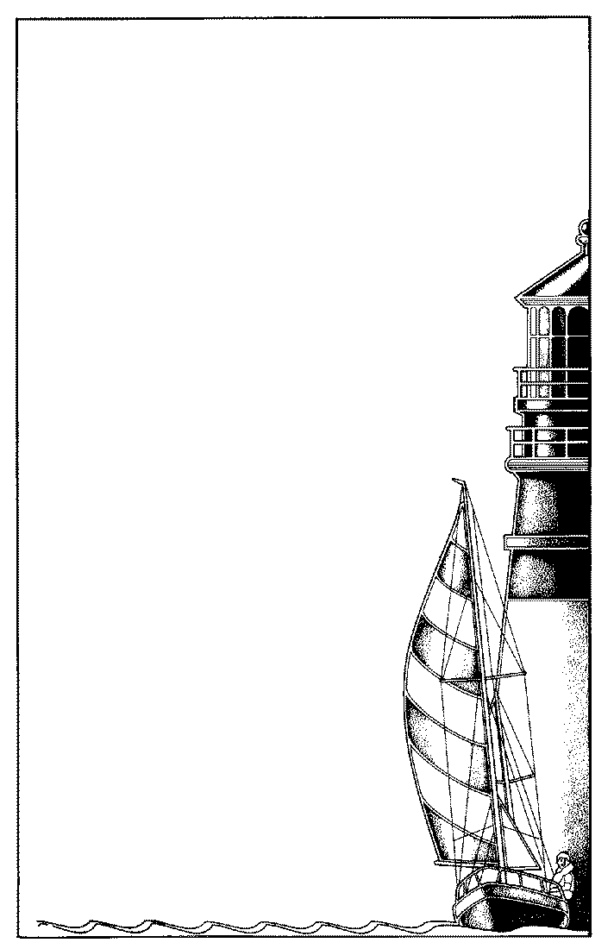

But the path of the Just is as a

Shining Light that shineth more and more unto the Perfect Day

Proverbs 4:18

**A Guiding Light to the Next Generation**

Student:

Grade:

Year:

**Seoul Christian School**

**Early Elementary**

**Progress Report**

|  |  |  |  |  |
| --- | --- | --- | --- | --- |
|  | **1** | **2** | **3** | **4** |
| **BIBLE** | A | A |  |  |
| Shows knowledge of Bible lessons | 1 | 1 |  |  |
| Applies Bible principles in work and play | 1 | 1 |  |  |
| Learns Bible verses | 1 | 1 |  |  |
| **Phonics and Reading** | B | B |  |  |
| Associates letters with sounds (phonics) | 2 | 2 |  |  |
| Identifies sounds in spoken words (phonemic awareness) | 1 | 1 |  |  |
| Associates letters with sounds (phonics) | 2 | 2 |  |  |
| Reads vowel-consonant patterns correctly in words (phonics) | 3 | 3 |  |  |
| Comprehends facts and details from silent reading | 1 | 1 |  |  |
| Evidences higher levels of comprehension from silent reading | 2 | 2 |  |  |
| Communicates meaning in oral reading (fluency, expression) | 3 | 3 |  |  |
| Demonstrates comprehension on worktext pages | 1 | 1 |  |  |
| Demonstrates knowledge of basic reading skills |  | 2 |  |  |
| **ENGLISH/Language Development** | B | B |  |  |
| Listens for comprehension | 1 | 1 |  |  |
| Expresses ideas orally | 2 | 2 |  |  |
| Composes oral sentences |  | 3 |  |  |
| Expresses ideas in writing |  | 2 |  |  |
| Uses simple sentence mechanics (proper capitalization and punctuation) | 2 | 2 |  |  |
| **SPELLING** | C | C |  |  |
| Spells words with common spelling patterns | 2 | 2 |  |  |
| **HANDWRITING** | A | A |  |  |
| Holds pencil correctly | 1 | 1 |  |  |
| Positions paper correctly | 1 | 1 |  |  |
| Uses good handwriting posture | 1 | 1 |  |  |
| Attempts correct letter and numeral formations | 1 | 1 |  |  |
| Writes neatly and legibly | 1 | 1 |  |  |
| **MATH** | B+ | B+ |  |  |
| Recognizes numerals | 1 | 1 |  |  |
| Understands place value (tens/ones) |  | 2 |  |  |
| Understands concept of addition | 2 | 2 |  |  |
| Understands concept of subtration | 2 | 2 |  |  |
| Knows math facts | 1 | 1 |  |  |
| **HERITAGE STUDIES/SCIENCE** | B | B |  |  |
| Participates in discussion and group activities | 1 | 1 |  |  |



Spiritual & Social Record

Academic Record

|  |  |  |  |  |
| --- | --- | --- | --- | --- |
| **RELATED ARTS** | **1** | **2** | **3** | **4** |
| Art | 1 | 2 |  |  |
| Music | 1 | 2 |  |  |
| Physical Education (TaeKwonDo) | 1 | 2 |  |  |
| Chinese | 2 | 2 |  |  |
| Computer | 2 | 2 |  |  |

and stature…

|  |  |  |  |  |
| --- | --- | --- | --- | --- |
| **Physical growth** | | | | |
| Practices good health habits | 1 | 1 | 1 | 1 |
| Participates in physical activities as able | 1 | 1 | 1 | 1 |

and in favor with **God**

and man.

|  |  |  |  |  |
| --- | --- | --- | --- | --- |
| **PERSONAL AND SOCIAL GROWTH** | | | | |
| Accepts responsibility | 2 | 2 | 2 | 2 |
| Demonstrates self-control | 3 | 3 | 3 | 3 |
| Respects authority (obedient and cooperative) | 2 | 2 | 2 | 2 |
| Handles property responsibly | 1 | 1 | 1 | 1 |
| Interacts well with other children | 1 | 1 | 1 | 1 |
| Shows kindness and respect toward peers | 2 | 2 | 2 | 2 |
| **WORK AND STUDY HABITS** | | | | |
| Listens an follows directions | 2 | 2 | 2 | 2 |
| Participates in the learning process | 1 | 1 | 1 | 1 |
| Completes work in a timely manner | 2 | 2 | 2 | 2 |
| Works well independently | 2 | 2 | 2 | 2 |
| Is neat and organized | 1 | 1 | 1 | 1 |
| **ATTENDANCE** | | | | |
| Days present | 40 |  |  |  |
| Days absent | 5 |  |  |  |
| Times Tardy | 0 |  |  |  |

Grading Key

|  |
| --- |
| A Excellent B Good C Average D Below Average F Unsatisfactory |
| 1 Very Good 2 Satisfactory 3 Needs Improvement 4 Unsatisfactory |